Chapter 4, Problem 50.

Obtain the Norton equivalent of the circuit in Fig. 4.116 to the left of terminals a-b. Use the result to find current i

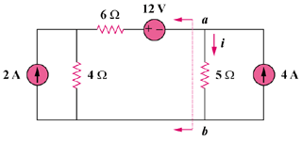

Figure 4.116
For Prob. 4.50.

